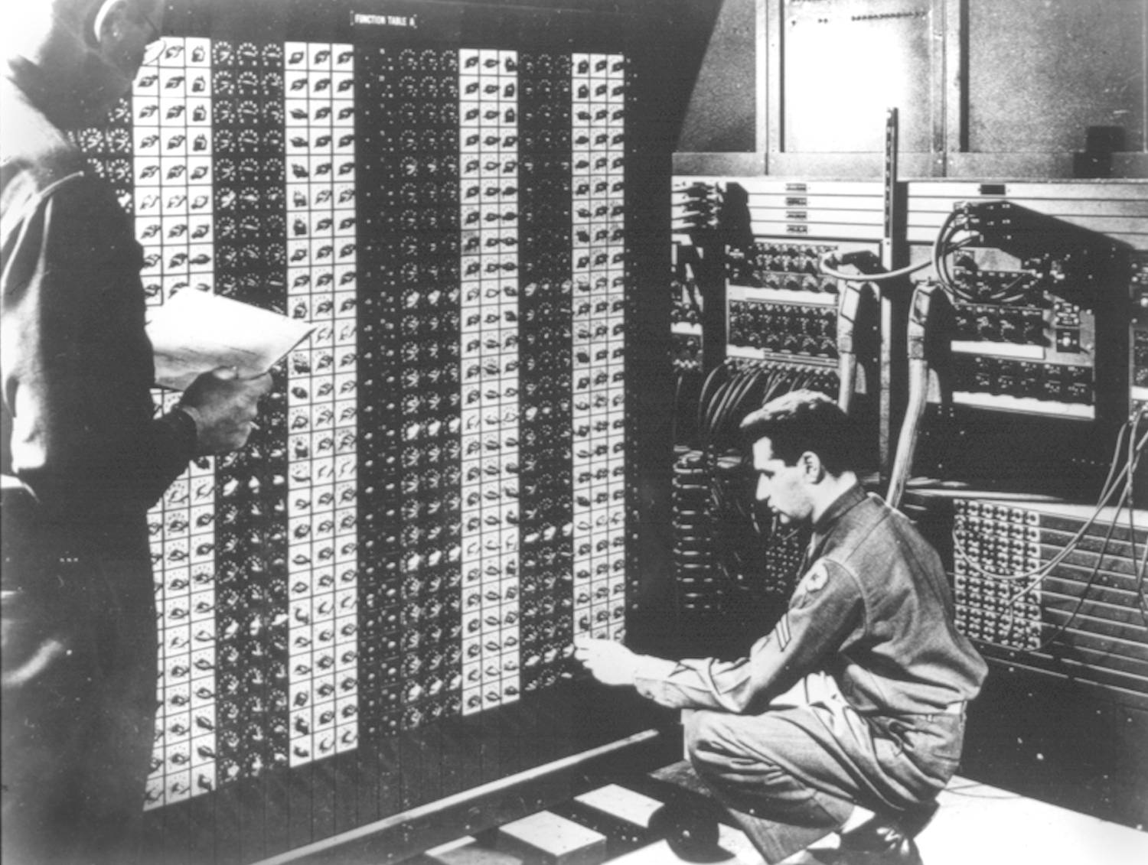 

**Advanced Placement Computer Science**

**Unit 9: Recursion**

Lesson: The Coolness that is recursion

*Last Updated: 1/15/2013*

“Men have become the tools of their tools” Henry David Thoreau

A recursive method is

Example

public int factorial(int x)

{

if (x ==

return

else

return

}

But how does this work?

Anything that can be done recursively can be done ________________________

Factorial Example

public int factorial(int x)

{

}

General Form of a Recursive Function:

Where recursion excels:

Where recursion stinks:

You try:

Write a recursive function to sum the digits of a number

Fibonacci Recursive Function (more than one base case)